 | POSITION:  Reports to:  Approved:  Revised:  Department:  FLSA: | JOB DESCRIPTION  Nurse Practitioner / Physician Assistant  Chief Medical Officer  August 1, 2019  July 18, 2019  Clinical Operations  Exempt
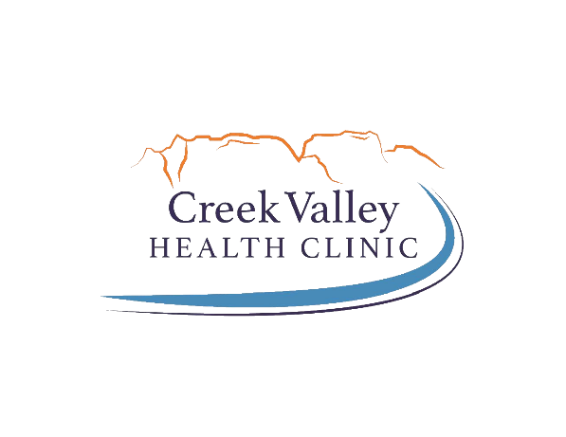
Basic Function: Reporting to the CMO, the mid-level medical practitioner (NP/PA) is responsible for the delivery of direct high-quality healthcare services. This position will assist with all aspects of primary care, including diagnosis, treatment, consultation, and education. The incumbent should demonstrate values that promote improved patient outcomes, sensitive treatment plans, and high patient satisfaction. This employee will serve as a key advisor to the CMO regarding clinical focus areas, policies, and procedures.

Primary Functions:

- Identifies the health status of patients by taking medical histories, performing examinations and initiating and evaluating screening and diagnostic procedures

- Assists in the coordination of services with other disciplines and patient’s insurance plans;

- Determines which cases to refer to the physician for further diagnosis and treatment

- Assumes principle responsibility for the primary health maintenance of individuals of all ages with a complete spectrum of health problems

- Initiates appropriate therapeutic intervention based upon assessment and evaluation of the health status of the individual and explains disease process to patient

- Documentation/Completion of EHR/Medical Records and keep case histories in accordance with the corporation’s procedures

- Plans and assumes responsibility for on-going health maintenance and clinical management of patients’ emotional behavior, counsels and instructs individuals and families regarding domestic and health related problems

- Evaluates patients’ emotional behavior, counsels and instructs individuals and families regarding domestic and health related problems

- Interprets and reviews laboratory tests; reviews medication refills

- Initiates orders for diagnostic laboratory and x-rays

- Serves as clinical consultant to medical assistants, nurses, and other clinical personnel

- Performs nursing duties when necessary

- Coordinates work activities with families, community agencies and other members of the health team and has a thorough knowledge of community resources

- Performs additional tasks appropriate to background and training as assigned

- Quality of care (Quality Measures) and participation in Peer Review

- Analyzes and recommends any needed areas of improvement/development. Monitors, documents, and reports progress toward identified goals and objectives.

- Provides medical direction for laboratory, pharmacy, occupational health, and other ancillary services and staff.

- Complies with CVHC Standards of Conduct and Corporate Compliance.

Secondary Functions:

- Understands role in Disaster Plan and that safety is a condition of employment.

- Follows CVHC’s policies and procedures.

- May serves on various CVHC and community committees as requested.

- Attends meetings, seminars, and conferences as appropriate to ensure skills and knowledge remains current.

- Other duties as assigned.

Minimum Qualifications:

- Licensed Nurse Practitioner or Physician Assistant in the State of Arizona (dual-licensed in Utah preferred)

- CPR certified.

- Ability to be credentialed with all Creek Valley Health Clinic’ contracted insurance plans and local area hospital(s).

- Experience working with EMR/EHR systems.

- Ability to read, analyze, interpret and compose general correspondence, reports, legal documents, etc. as required.

- Commitment to improving health status of medically underserved communities.

- Ability to read, write and speak clearly understandable English.

- Possess a valid driver’s license - ability to travel and be flexible in carrying out the course of duties.

- Good interpersonal and human relations skills are required. Must possess skills to empathize and care for a variety of patients, including low-income and diverse cultures and treat everyone (internal and external customers) with respect and dignity.

- Ability to maintain confidentiality at all times in all situations and follow the laws and intent of the most current HIPAA laws and regulations and Creek Valley Health Clinic’ security and privacy policies.

Preferred Qualifications:

- Previous experience as a FNP or PA in a community / rural clinic setting

- Previous experience working in a Federally Qualified Health Center

- ACLS (Advanced Cardiovascular Life Support), NRP (Neonatal Resuscitation Program), PALS (Pediatric Advanced Life Support).

- Licensed Nurse Practitioner or Physician Assistant in the State of Utah

- Firm understanding of Colorado City, Hildale, and the surrounding area.

- Working knowledge of all Microsoft programs.

Appearance Standards:
This position shall follow the appearance standards as outlined in Creek Valley Health Clinic’ Personnel Policy “Dress and Personal Appearance”.

Physical Requirements:
Medical Clinical Staff - All Levels
 | Not Applicable | Occasionally | Frequently | Constantly
Stand |  |  | X
Vision - near |  |  |  | X
Vision – w/assistance |  |  |  | X
Walk |  | X
Sit |  |  |  | X
Handling |  |  |  | X
Reach outward |  |  | X
Reach above shoulder |  |  | X
Climb | X
Crawl | X
Squat/kneel |  | X
Bend |  | X
Lift/Carry
10 lbs or less |  | X
11-20 lbs |  | X
21-50 lbs |  | X
51-100 lbs |  | X
Over 100 lbs | X
Push/Pull
12 lbs or less |  | X
13-25 lbs |  | X
26-40 lbs |  | X
41-100 lbs | X
Not applicable | Activity does not apply to this position
Occasionally | Position requires this activity up to 33% of the time (0-2.5 hrs per day)
Frequently | Position requires this activity from 33%-66% of the time (2.5-5.5 hrs)
Constantly | Position requires this activity more than 66% of the time (5.5 hrs +)

OSHA CATEGORY CLASSIFICATION:
I understand that the duties that are required of me place me in a Category I.

While performing the duties of this position, the employee is exposed to weather conditions prevalent at the time. The employee may experience exposure to dust, pollens, pollutants, fumes, and communicable diseases as related to the health care environment. The noise level in the work environment is usually moderate.

Travel is is not required. It is anticipated that travel will be: 5% – 10% 50%-75%
10% – 25% 75% - 90%
25% – 50%

The specific statements shown in each section of this Job Description are not intended to be all-inclusive. They represent typical elements and criteria considered necessary to perform the job successfully. The job’s responsibilities/tasks may be modified and/or expanded over time. Creek Valley Health Clinic will inform the employee when changes in the respective job description are made.

I have read and understand the duties / physical requirements indicated in this job description and acknowledge that I am able to perform these duties with or without reasonable accommodation. I understand that failure to adhere to these responsibilities could be grounds for disciplinary action.

___________________________________________________________________________________
Print Name Signature Date

